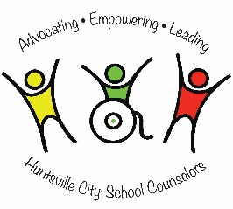

PRINCIPAL’S COMMENTS: LYNETTE ALEXANDER

Our school counseling program is vital to our students’ academic, personal/social, and career growth. The program is data-driven and student centered. The counselor offers guidance lessons based on American School Counselor Association (ASCA) National Standards, as well as individual counseling and small group counseling which prepares our students to become life-long learners and leaders in their community. The school counseling student support team (SCSST), led by the counselor, collaborates with our parents and community stakeholders to promote academic success and a supportive school environment for our students.

School Counseling Student Support Team (SCSST):

The success of MLK is built upon the support, involvement and dedication of administration, students, teachers, parents and stakeholders. The SCSST is led by a full-time counselor who holds a Master’s Degree in School Counseling from Auburn University, is a member of both the American School Counseling Association (ASCA) and the Alabama Counseling Association (ALCA) and is a Nationally Certified Counselor (NCC). The counselor collaborates with other local Huntsville City school counselors, counselor advisory committee, school administrators, classroom teachers, collaborative teachers, technology staff, gifted teachers, classroom aides, reading coaches, school secretary, librarian, school nurse, instructional partner, curriculum specialist, speech teacher, custodians, community partners and volunteers, parents, and support staff including physical education, art, music, and library. The school counselor designs, coordinates, implements, and evaluates an equitable support system to serve all students.

School climate and safety

At MLK, school climate and safety is fostered through two programs: the Anti-Defamation League’s *No Place for Hate* program and *Positive Behavior Intervention and Strategies.* Both of these programs foster relationships with our faculty, students, and parents to promote a positive learning environment and a school that does not tolerate bullying. The counselor taught large group counseling classes focused on anti-bullying, conflict resolution skills, social acceptance, peer pressure, and anger management. Small group were formed that focused on behavior in the classroom, bereavement, social skills and anger management. The SCSST helped implement Red Ribbon Week which promoted school safety by raising an awareness of the dangers of drug and alcohol abuse. Our Peer Helpers worked with kindergarten through second grade students to help mature their academic and social skills. The SCSST also helped implement a school wide behavior incentive program to increase positive behavior.

**R.A.V.E. R**ECOGNITION OF **A**CCOUNTABILITY, **V**ERIFICATION AND **E**XCELLENCE 2015-2016

Sponsored by Alabama School Counselor Association (ASCA)/Supported by Alabama State Department of Education

**MLK SCHOOL CLIMATE SURVEY 2015**

At MLK, our SCSST works diligently to promote and support the school’s mission of helping students learn and grow as leaders. The role of the school counselor is vital to maintaining relationship with the faculty, students, and parents to meet the needs of the school and foster a safe and welcoming environment. The results of the surveys show that a majority of our students, faculty, and parents feel safe and welcome at our school. More of our teachers reported feel less safe/happy this year than last year which may be due to a change in administration.

**Q #2: CLIMATE:** I/My children feel welcome at school.

Students: Y 95.27%, N 4.73%

Teachers: Y 74.19%, N 25.81%

Parents: Y 93.72%, N 6.28%

**Q #1: SAFETY:** I/my children feel safe at school.

Students: Y 94.63%, N 5.37%

Teachers: Y 71.43%, N 28.57%

Parents: Y 94.74%, N 5.26%

|  |  |
| --- | --- |
| |  | | --- | | **Martin Luther King Jr. Elementary (MLK)**  3112 Meridian Street Huntsville, Alabama 35806  (256) 428-7100 www.martinlutherkingjrelementary.org  Lynette Alexander, Principal Sarah Spear, Counselor Enrollment: 450 Grades: PK-5  School Year: Traditional | |
| |  | | --- | |  | | |

STUDENT RESULTS

The results of MLK’s students are a demonstration of the successful implementation of the ASCA National Standards. The data is collected throughout the school year and is analyzed to address the needs quickly and effectually. The outcomes of the students’ results will provide useful information to help meet the needs of our students and promote support from the staff, parents, and our stakeholders.

|  |
| --- |
| **Digital Citizenship:**  (PS.A1.6, PS.A1.7, PS.C1.2)  Third, fourth and fifth grade students learned about the definition of digital citizenship. We also discussed the different ways to tell if a website is safe. Before the lesson, 56.67% of the students were able to correctly identify “safe” websites. After the lesson, 73.75% were able to correctly identify “safe” websites. The following week, we reviewed the way to identify safe websites, and 100% of the students correctly identified the “safe” website. The students are now able to be safe citizens when they are on the internet. |

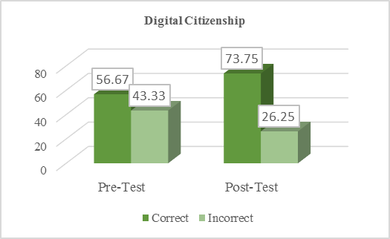

MAJOR ACHIEVEMENTS

The MLK school counseling program is committed to improving the department and aligning with the school’s improvement plan. For 2016-2017 we will: 1) provide additional training to staff and faculty, parents, and students on our PBiS and *No Place for Hate* to decrease bullying and increase acceptance in our school; 2) collaborate with teachers and administrators about increasing opportunities for student leadership through our *Leader in Me* program; and 3) create a stronger focus on career readiness through classroom guidance lessons and a school-wide Career Day.

FOCUS FOR IMPROVEMENT

Keeping you informed

The collaboration of the MLK School Counselor with the Huntsville community and surrounding areas has greatly contributed to the success of students and provides valuable services to our families and staff.

**Academic:** Boys and Girls Club tutoring, Free to Teach provides supplies, Appleton Learning Center classroom aides, Girls Inc provides tutoring and after school mentoring, volunteer tutors. **Career:** Huntsville Fire Department for fire safety training, Community Speakers (fire, police, mayor) for Career events, Volunteer Tutors from Alabama A&M. **Personal/Social:** The Manna House provides weekend meal packs, United Way of Madison County provides at-home support, Anti-Defamation League supports our NP4H8 program, Crisis Services of North Alabama for mental health services, H.E.A.L.S. Clinic provides dental, vision, and health services on site.

PARENT/GUARDIAN INVOLVEMENT

Parental involvement is highly encouraged at MLK to become a partner in their student’s success by participating in their academic, career, and personal/social development. Below are the many opportunities available to parents:

Parental participation on the Guidance Advisory Committee, completion of parent needs assessment, Parent Teacher Association (PTA) membership, Title I Annual Parent Meetings, chaperone for field trips, Field Day volunteers, and volunteer for tutoring.

Please contact Sarah Spear at [sarah.spear@hsv-k12.org](mailto:sarah.spear@hsv-k12.org) or by phone, (256) 428-7100 for more information.

cOMMMUNITY pARTNERSHIPS/rESOURCES

The MLK counseling program shares information with parents, students, faculty and the community through the following means:

**Personal Contact:** parent conferences, school tours, Open House, PTA meetings, faculty meetings, grade-level meetings, Problem Solving Team (PST) **Electronic:** MLK newsletter, email, phone calls, school counseling website, posts on Edmodo, school announcements, educational DVDs **Print:** *The Huntsville Times,* classroom newsletters, bulletin boards, school counselor pamphlet, school marquee, and written announcements sent home*. A*ll essential information is provided in the primary language(s) of the students’ families.

Data is collected throughout the year and the assessment results are used by the SCSST to measure academic growth, attendance, and behavior. The results are used to ensure that all the student’s needs are being met.

Academic: The following assessments are used to identify areas of academic achievement to facilitate our Response to Intervention: *Dynamic Indicators of Basic Essential Literacy Skills (DIBELS,* grades K-2), ACT Aspire (grades 3-5), SchoolNet Benchmark (grades K-5), STAR Enterprise Reading and Math Assessment (grades 1-5), The Assessing Comprehension and Communication in English State to State for English Language Learners (ACCESS), and Special Education Assessments to provide data about discrepancies between the students’ ability and achievement. Career: All students participated in Huntsville City Schools College and Career Readiness Week activities. Students in grades 2-5 learned about career clusters and how careers are classified.. They also researched career interests online through O*Net. Personal/Social: The school nurse conducts health screenings to identify any health barriers to student success, Parent/Teacher/Students needs assessments to determine the needs for our school to guide the Guidance Advisory Committee, and discipline and attendance records are tracked which helped identify students at risk.

ACADEMIC, cAREER, AND pERSONAL/sOCIAL mEASUREMENTS

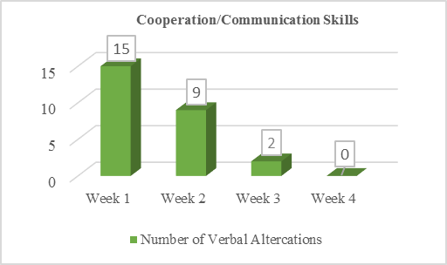

**Career Clusters Skills**

(C:A1.2, C:B1.2, C:C1.3)

The second, third, and fourth grades students learned about career clusters and the skills that would be required in each cluster. Before the lesson, 37.8% of students could correctly identify three skills they would need in their potential future career. After the lesson, 69.6% of students could correctly identify three skills they would need in their potential future career. Through the lesson and the research the students conducted, they have a better idea of skills they would need in their future career choice.

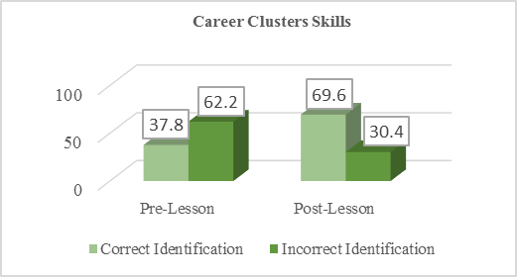

**Cooperation/Communication Skills**

(A.A2.3, A.A3.2)

The third, fourth, and fifth grade students learned four lessons about cooperation. Each week they participated in activities to focus on cooperation, teamwork, and communication skills. The first week, there were 15 verbal altercations during the activity. By the end of the month, there were 0 verbal altercations during the activity. Through participating in the lessons, the students were better able to work in teams and they improved their communication skills.

MLK Counselor is a National Certified Counselor (NCC)

RAVE Bronze Award Recipient (2015)

Implemented *No Place for Hate (NP4H8)* at MLK (2013-2016)

Trained all faculty in (PBIS) Positive Behavior Intervention and Support to strengthen our anti-bullying program

Developed and coordinated a Peer Helper program for third through fifth graders to work with kindergarten through second grade students to develop reading skills

Worked with Student Council to collect pennies for Project Penny to collect money for student projects

Team leader for Huntsville City Schools Learning Supports Committee

major achievements